Power (P) = $\frac{energy}{time}$ = $\frac{work}{time}$

SI Unit of Power: Watt (W): W = $\frac{Joule (J)}{Seconds (S)}$

Intensity (I) = $\frac{energy}{area * time}$ = $\frac{power}{area}$

SI Unit of Intensity: $\frac{W (watts)}{meter(M)^{2}}$

Light bulb example

Information

* Surface area = 4m2
* Bulb intensity of 100 W (Power)
* I = $\frac{100 W}{4m^{2}}$
  + I = 25 $\frac{w}{M^{2}}$

Solar constant

Information

* d = 93,000,000 → $9.3 * 10^{7}$ miles
* What is the intensity of sunlight at 12:00 on a clear day?
* I = 1370 $\frac{w}{m^{2}}$

**Light (E.M waves) from surface (2 types)**

1. With room lights ON:
   1. Room light shine on blue book:
      1. Can see book
      2. Cannot see when light is turned off
   2. → Re-radiation from surface
2. With room lights OFF:
   1. Cannot see book however book still releases electromagnetic waves!
      1. It “glows” via infrared waves
      2. Thermal radiation from surface

Infrared Waves cont.

* All objects spontaneously emit electromagnetic radiation
* The amount and the **ƛ** (wavelength) of this radiation depends on temperature “T”
* Put any object in a dark room
  + The object will “glow” depending on the temperature
* Example one [Electric stove burner]:
  + Light intensity (thermal radiation) “I” depends on wavelength

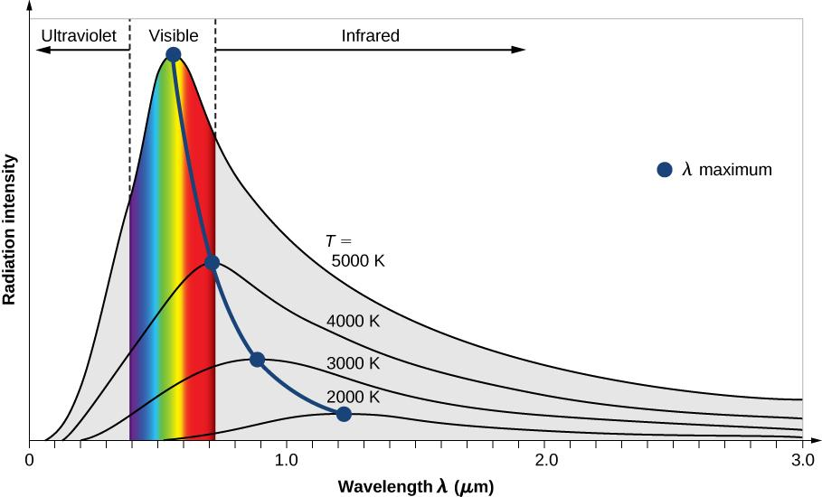

Thermal Radiation

* I = total intensity for all wavelengths
* Find:
  + Temperature is in Kelvin
  + I = $constant * T^{4}$ ← (Stafan-Boltzmann Law)
* Scaling: $I_{i} , I_{f} ; T_{i} , T_{f}$
* $\frac{I_{f}}{I_{i}} = \frac{constant * {T_{f}}^{4}}{constant * {T_{i}}^{4}}$ → $\frac{I_{f}}{I_{i}} = \frac{ {T_{f}}^{4}}{ {T_{i}}^{4}}$ → $\frac{I_{f}}{I_{i}} = (\frac{ T_{f}}{ T_{i}})^{4}$
* Example: Double the temperature and how does the intensity change?
  + $T_{f}= 2*T_{i}$ → $\frac{I_{f}}{I_{i}} = (\frac{ T_{f}}{ T_{i}})^{4}$ → $(\frac{2T_{i}}{T_{i}})^{4}$ → $(2)^{4}$ → 16 (times brighter)